**13 - ServiceNow Reporting Tutorial**

Reports allow you to visualize and analyze ServiceNow data. You can represent data in various formats, such as bar charts, pie charts, dials, lists, pivot tables, and donuts.

Reports can be run manually or set to run automatically on a schedule. ServiceNow provides predefined reports for applications and features like Incident Management and Service Catalog requests, including Key Performance Indicator (KPI) reports.

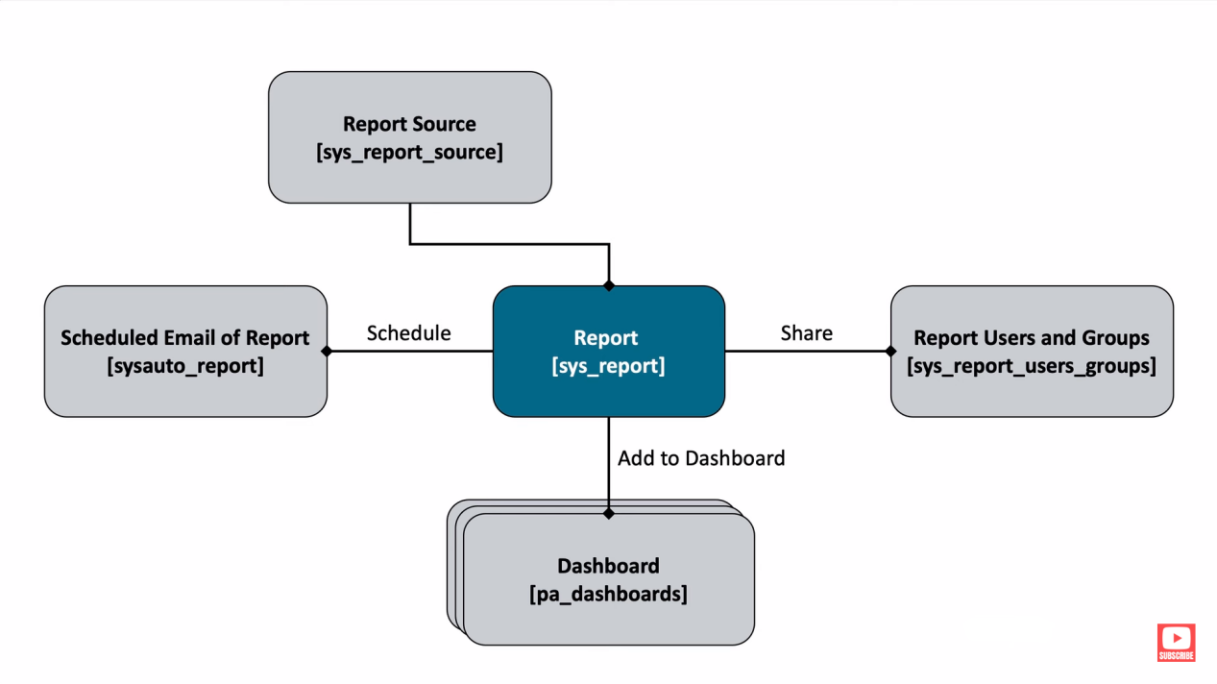

**Types of reports -**

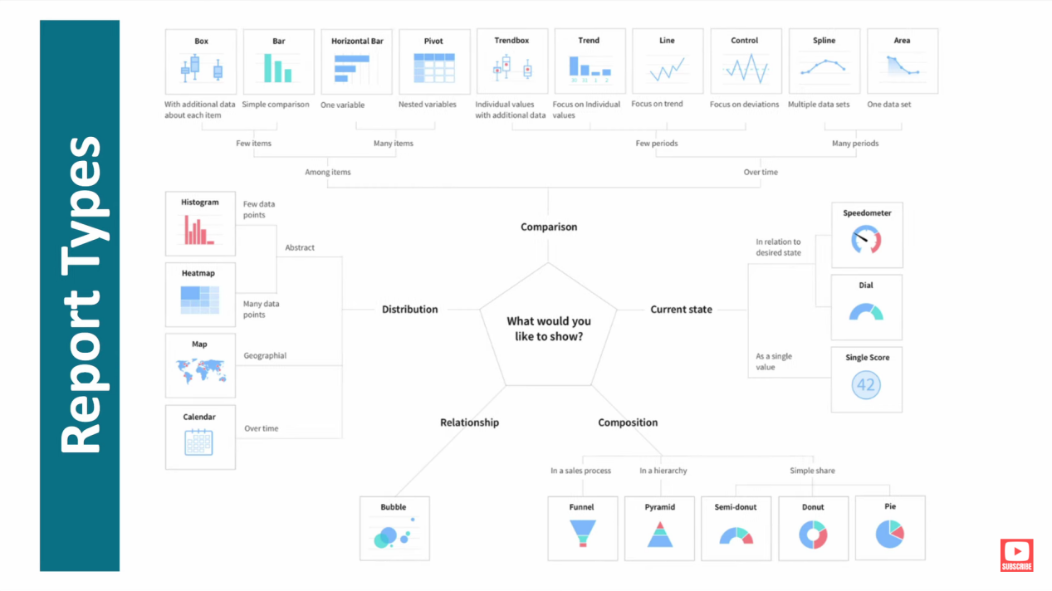

**Creating and Managing Reports -** To view and run reports, go to *All > Reports > View / Run*. This area includes a variety of reports you can run and customize. Some reports come with the Platform, while others might be made by your company’s reporting admins.

**To create or modify a report** -

Create a Report - Click to start a new report or select an existing one.

Data - Name your report and choose the source (which ServiceNow table) for your data.

Type - Pick how you want your report to be visualized. There are over 25 types to choose from, such as bar charts, pie charts, etc.

Configure - Organize your data by grouping fields and running calculations.

Style - Customize the appearance of your report, including colors, titles, and the legend.

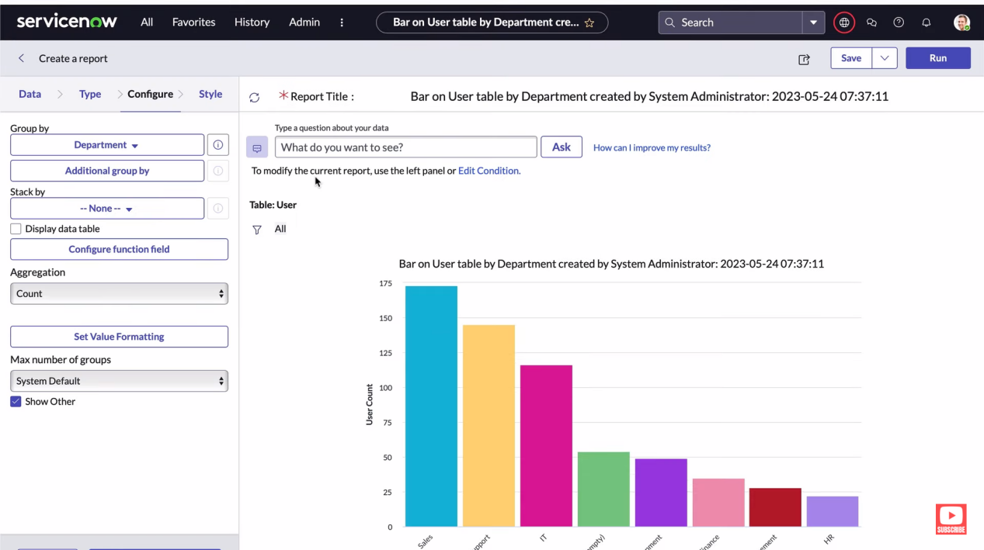

**Creating Reports from a List -**

**Filter Data -** Apply a filter to the list to show only the data you want to report on. For example, you might filter incidents to show only those where the Caller field is not empty.

**Create Chart -** Click on the column menu for the Caller field and choose either Bar Chart or Pie Chart to visualize the data.

**Share reports with users, groups, or via dashboards** - When sharing a report, you can make it visible to users who are logged into ServiceNow.  
  
**Add to Dashboard -** To add a report to a dashboard, first save the report by clicking "Save and Continue." Then choose the dashboard and tab where you want the report to appear.

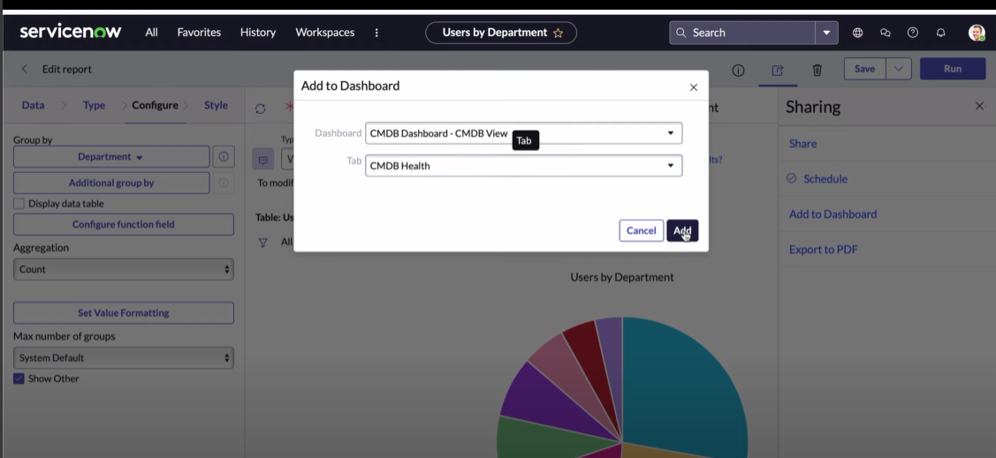

ANANYA CHOUDHARY